Geoguessr enjoyers

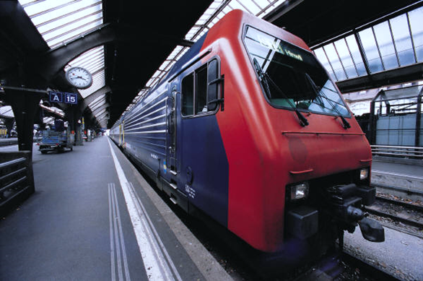

Table of Contents

Team 2

Goal 2

Task 2

Technologies and languages used 2

Functions 3

# Team

The people, which are a part of this project, are:

* Georgi Zhekov, 10V - gtzhekov20@codingburgas.bg
* Mario Zlatev, 10V - mizlatev20@codingburgas.bg
* Ivan Draganov, 10B - irdraganov20@codingburgas.bg
* Nikola Krushkov, 10B – ntkrushkov20@codingburgas.bg

# Goal

А text game in which you play as a person travelling around the world. Answer the questions right and win points!

# Task

We made a meeting and decided on the idea. We assigned everyone roles and decided how the game would work. We began working on the game and finished it in time.

# Technologies and languages used

* Teams
* Visual Studio
* Visual Studio Code
* GitHub

# Functions

|  |  |
| --- | --- |
| Functions | Designation |
| gotoxy(); | Choose the coordinates  where to draw elements or text. |
| colorSelection(); | Changes the color of the text. |
| mainMenu(); | Prints the main menu of the game. |
| game(); | This is the introduction to the game. |
| gameOver(); | This function ends the game. |

